***Tableau assignment 2 solutions***

Question-1: Tableau data engines is the tableau’s in-memory data engine technology optimized for fast data ingests and analytical query processing on large or complex data sets.

Questino-2: To create a calculated field, click on the arrow dropdown button and then click on the ‘Create Calculated Field’ button. Then a new window will be opened. Provide the formula for your calculated field in that window and then click on ok. It is important to note that the newly calculated field will only work if the provided formula is correct.

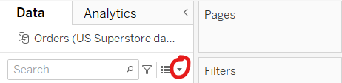

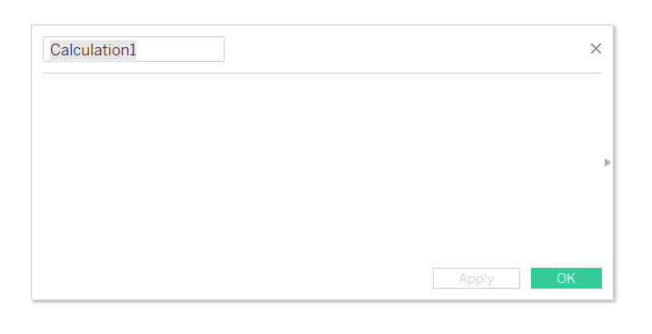

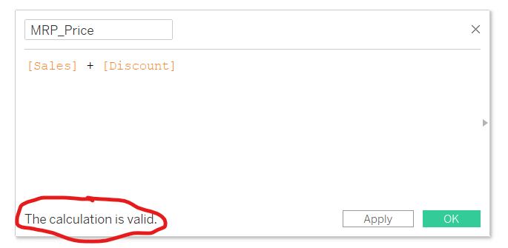

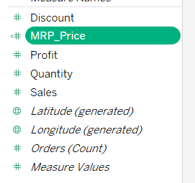

Question-3: Heatmap are ideal to visualize how big or small the numbers which are related to some scale. For example, if you use the heatmap over the correlation of features of a table then it would be very easy to interpret the values using the heatmap rather than looking at the correlation matrix directly. Tree maps are very useful when we want to display very large amount of hierarchical tree structured data.

Question-4: Tableau dashboard has following basic components:

1. Web: It consists of a web page embedded in the dashboard
2. Horizontal component: It is a kind of horizontal container for the different graphs
3. Vertical components: It is a vertical component for the different tableau graphs
4. Image extract: This element allows you to upload a image to a dashboard
5. Text: It is an area where we can add some text such as heading or some other info about the graphs.

Question-5:

a.

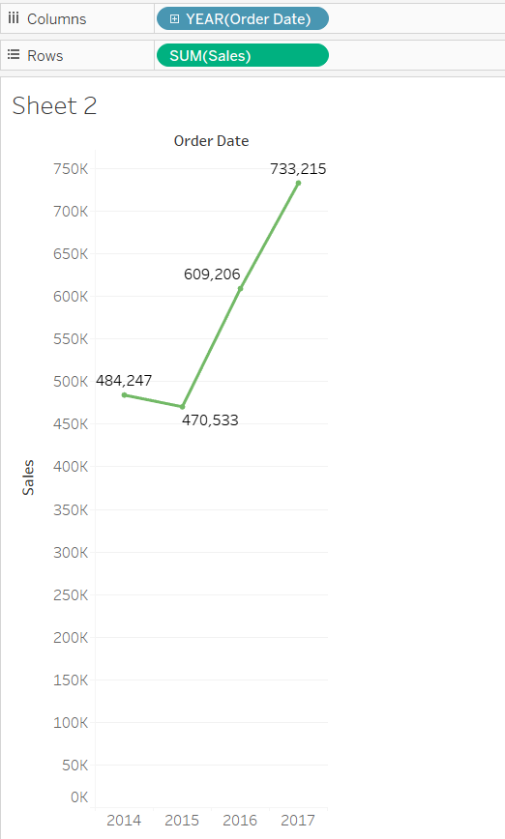

c.

